**Chapter 4**

4.1 A program displays the right-most digit of the integral part of the number #include<stdio.h>

int main()

{ int a,e; printf("Enter the value of a\n"); scanf("%d",&a); e=a%10;

if(a>10) printf("%d\n%d\n",a,e);

}

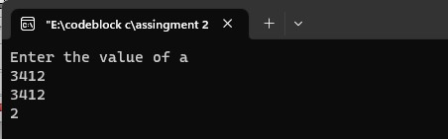

Modify the above program to display the two rightmost digits of the integral part #include<stdio.h>

int main()

{

int a,e; printf("Enter the value of a\n"); scanf("%d",&a); e=a%100; if(a>100) printf("%d\n%d\n",a,e);

}

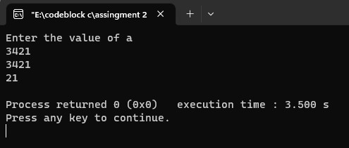

Given an integer number, write a program that displays the number as follows: First line : all digits Second line : all except first digit Third line : all except first two digits

#include<stdio.h> int main() { int n,i,x; printf("Enter the number: "); scanf("%d",&n); for(i=n;i>=1;i--)

{

for(x=1;x<=i;x++)

{

printf("%d ",x);

} printf("\n");

}

}

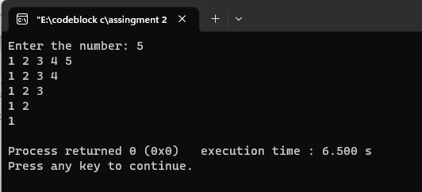

a program to determine the salvage value of an item when the purchase price, years of service, and

the annual depreciation are given

#include<stdio.h> int main()

{

//pp= purchase price;sv=salvage value;yos=years of service;

//dep=Depreciation float pp,sv,yos; float dep printf("Enter Purchase Price: "); scanf("%f",&pp); printf("Enter Depreciation: "); scanf("%f",&dep); printf("Enter Years of service: "); scanf("%f",&yos); sv=pp-(yos*dep); printf("Salvage value = %0.2f",sv); }

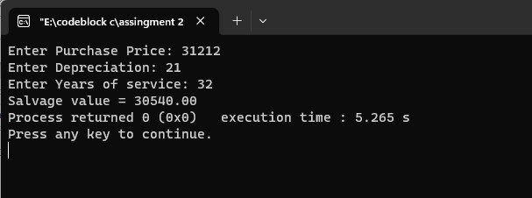

The total distance travelled by a vehicle in t seconds

#include<stdio.h> int main()

{

//a=acceleration;t=time;u=initial velocity;d=distance; float d,t,a,u; printf("Enter Initial velocity: "); scanf("%f",&u); printf("Enter Acceleration: "); scanf("%f",&a); printf("Enter time: "); scanf("%f",&t); d=(u*t+(a*t*t)/2); printf("The distance is : %0.3f",d);

}

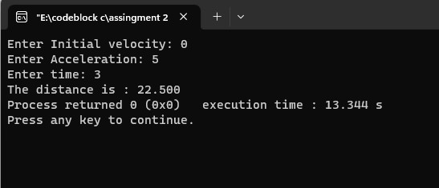

a program to compute EOQ and TBO, given demand rate (items per unit time), setup costs (per

order), and the holding cost (per item per unit time).

#include<stdio.h> int main() /* demand rate=dr ;setup cost = sc ;holding cost per item per unit time = hc ; */ { float TBO,EOQ,dr,sc,hc; printf("Enter demand rate: "); scanf("%f",&dr); printf("Enter setup cost: "); scanf("%f",&sc); printf("Enter holding cost per item per unit time: "); scanf("%f",&hc);

EOQ = sqrt((2*dr*sc)/(hc)); TBO = sqrt((2*sc)/(dr*hc)); printf("TBO is : %0.3f\n",TBO); printf("EOQ is : %0.3f\n",EOQ);

}

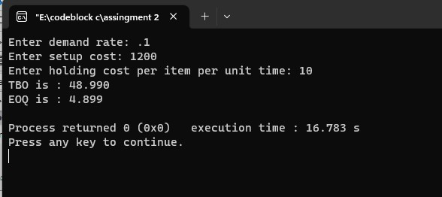

a program to calculate the frequency for different values of C starting from 0.01 to 0.1 in steps of

0.01.

#include<stdio.h> int main() { double r,c,l,fr;

//r=resistance;l=inductance;c=capacitance;fr=frequency; printf("Enter resistance: "); scanf("%lf",&r); printf("Enter inductance: "); scanf("%lf",&l); printf("Enter capacitance from 0.01 to 0.1: "); scanf("%lf",&c); fr=sqrt((1/(l*c))-((r*r)/(4*c*c))); printf("The Frequency is %0.2lf",fr);

}

a program to read a four digit integer and print the sum of its digits

#include<stdio.h> int main() { int n,sum=0,r,x; printf("Enter a number of four digits: "); scanf("%d",&n); while(n!=0){

r=n%10; sum=sum+r; n=n/10;} printf("Sum of digits are : %d",sum);

}

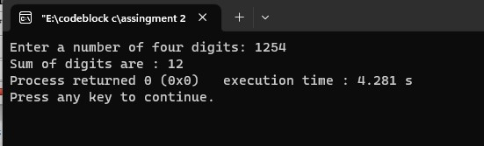

a program to read three values from keyboard and print out the largest of them without using if

statement. #include<stdio.h> int main() { int n1,n2,n3; printf("Enter 1st number: \n"); scanf("%d",&n1); printf("Enter 2nd number: \n"); scanf("%d",&n2); printf("Enter 3rd number: \n"); scanf("%d",&n3); int maximum = (n1> n2) ? ((n1 > n3) ? n1 : n3) : ((n2 > n3) ? n2 : n3); printf("Maximum value is : %d",maximum);

}

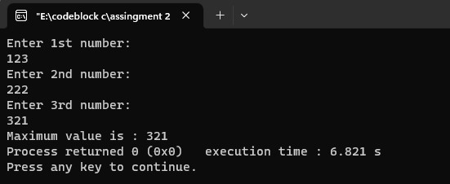

a program to read two integer values m and n and to decide and print whether m is a multiple of n.

#include<stdio.h> int main() { int m,n; printf("Enter a number(n): "); scanf("%d",&n); m=n*n; printf("The value of n is %d\n",n); printf("The value of m is %d\n",m); }

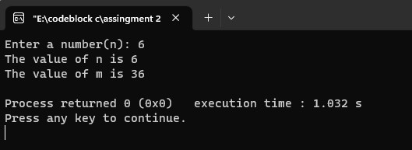

a program to read three values using scanf statement and print the following results: (a) Sum of

the values (b) Average of the three values (c) Largest of the three (d) Smallest of the three

#include<stdio.h> int main() { int n1,n2,n3; printf("Enter 1st number: \n"); scanf("%d",&n1); printf("Enter 2nd number: \n"); scanf("%d",&n2); printf("Enter 3rd number: \n"); scanf("%d",&n3); if(n1>n2&&n1>n3) printf("%d is large number. \n",n1); else if(n2>n1&&n2>n3) printf("%d is large number. \n",n2); else printf("%d is large number. \n",n3); printf("\n\n"); if(n1<n2&&n1<n3) printf("%d is small number. \n",n1); else if(n2<n1&&n2<n3) printf("%d is small number. \n",n2); else printf("%d is small number. \n",n3);

printf("\n\n");

int sum=n1+n2+n3;

float av= sum/3;

printf("The sum of three digits are: %d\n\n",sum); printf("The average of three digits are: %f\n\n",av); }

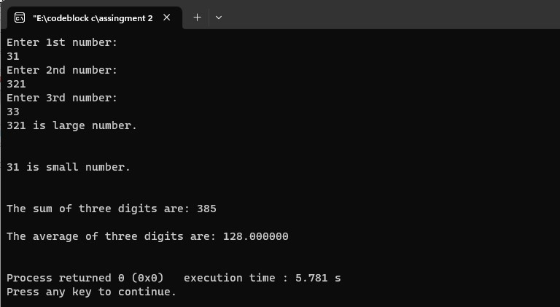

4.14 a program to print a table of sin and cos functions for the interval from 0 to 180 degrees in increments of 15

#include<stdio.h> #include<math.h> int main() { float x,y,i; printf("Angle sin(Angle) cos(Angle)\n"); for(i=0;i<=180;i=i+15)

{ x=sin(i); y=cos(i); printf("%0.2f %0.2f %0.2f\n",i,x,y); }

}

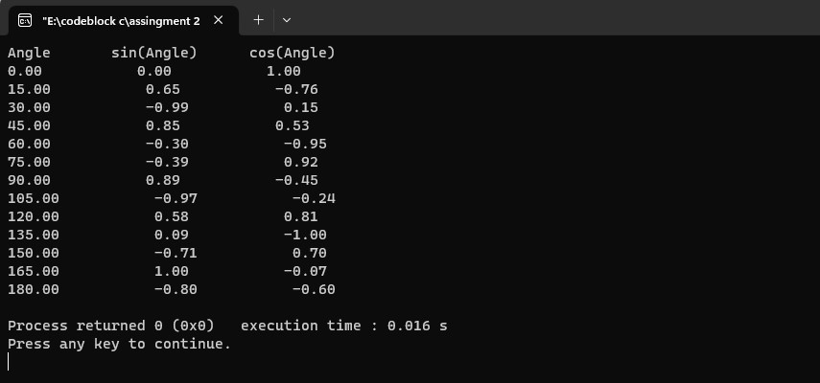

4.15 a program to compute the values of squareroots and squares of the numbers 0 to 100 in steps 10 and print the output in a tabular form

#include<stdio.h> int main() { float i,x,y; printf("Value square squareroot\n"); for(i=0;i<=100;i=i+10)

{ x=i*i; y=sqrt(i); printf("%0.2f %0.2f %0.2f\n",i,x,y);

}

}

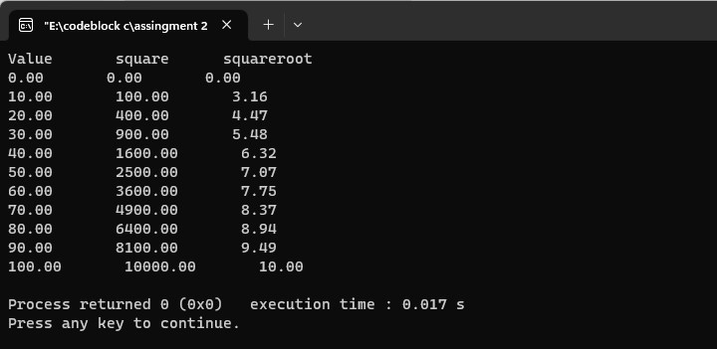

4.17 a C program to shift the given data by two bits to the left.

#include<stdio.h> int main(){

int d =5; printf("%d",(d<<2));

}

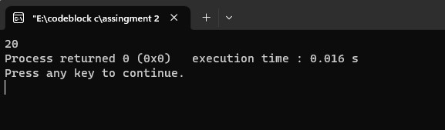

a C program to compute the value of the expression x=a-b/3+c*2-1.

#include<stdio.h> int main() { float a,b,c,x; printf("Enter a: "); scanf("%f",&a); printf("Enter b: "); scanf("%f",&b); printf("Enter c: "); scanf("%f",&c); x=a-b/3+c*2-1; printf("The value of x is = %0.2f",x); }

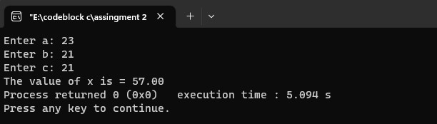

4.20 a C program to input a date value and determine whether the entered day, month, and year values are valid.

#include<stdio.h> int main() { int year,t,rd,rd2,month,week,days; printf("Enter days numbers: "); scanf("%d",&t);

//rh=remain second after getting hours year=t/365; rd=t%365; month=rd/30; rd2=rd%30; week=rd2/7; days=rd2%7; printf("Days are %d years, %d months, %d weeks, %d days",year,month,week,days);

return 0;

}

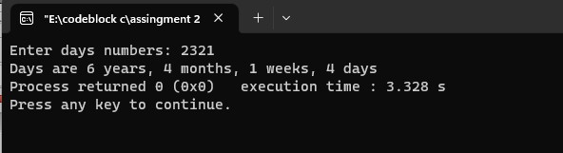

a C program to input the sides of a triangle and determine whether the triangle is isoceles or not.

#include <stdio.h>

int main() { int side1, side2, side3;

// Read the lengths of three sides of the triangle printf("Enter the lengths of three sides of the triangle: "); scanf("%d %d %d", &side1, &side2, &side3);

// Check if the triangle is isosceles or not if (side1 == side2 || side1 == side3 || side2 == side3) { printf("The triangle is isosceles.");

} else { printf("The triangle is not isosceles.");

}

return 0;

}

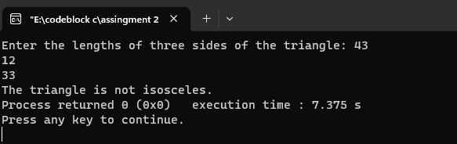

a C program that reads two numbers and performs their division. If the division is not possible,

then an error message, ‘Division not possible’ is displayed.

#include<stdio.h> int main() { float x,y,z; printf("Enter 1st value: "); scanf("%f",&x); printf("Enter 2nd value: "); scanf("%f",&y); z=x/y; if(y==0) printf("division not possible"); else printf("The division value is : %0.2f",z); }

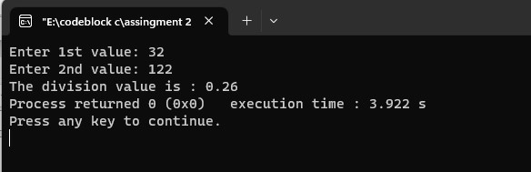

the value of 4 variables a, b, c and d and compute the resultant value of following expressions: (a + b) * (c / d) (a + b) * c / d a + (b * c) / d

#include<stdio.h> int main() { float x,y,z,a,b,c,d; printf("Enter a: "); scanf("%f",&a); printf("Enter b: "); scanf("%f",&b); printf("Enter c: "); scanf("%f",&c); printf("Enter d: "); scanf("%f",&d); x=(a+b)*(c/d); y=(a+b)*c/d; z=a+(b*c)/d; printf("The 1st value is: %0.2f\n",x); printf("The 2nd value is: %0.2f\n",y); printf("The 3rd value is: %0.2f\n",z); }

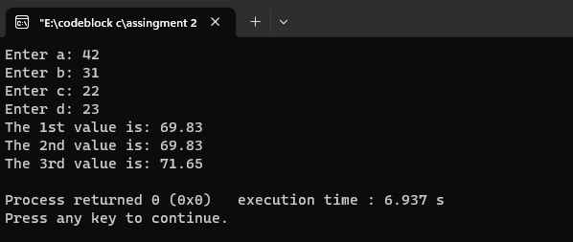

**Other programming exercise**

1. Pattern 1

#include<stdio.h> int main() {

int i,j,n;

printf("Enter raw number: "); scanf("%d",&n); for(i=1;i<=n;i++)

{ for(j=1;j<=i;j++)

{ printf("%d ",j);

} printf("\n");

}

}

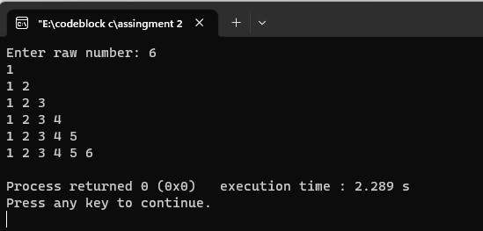

#include<stdio.h> int main() { int n,r,c; printf("Enter raw number:"); scanf("%d",&n); for(r=1;r<=n;r++)

{

for(c=1;c<=n-r;c++)

{ printf(" ");

}

for(c=1;c<=r;c++)

{ printf("%d ",c);

} printf("\n");

}

for(r=n-1;r>=1;r--)

{

for(c=n-r;c>=1;c--)

{ printf(" ");

}

for(c=1;c<=r;c++)\

{ printf("%d ",c);

} printf("\n");

}

}

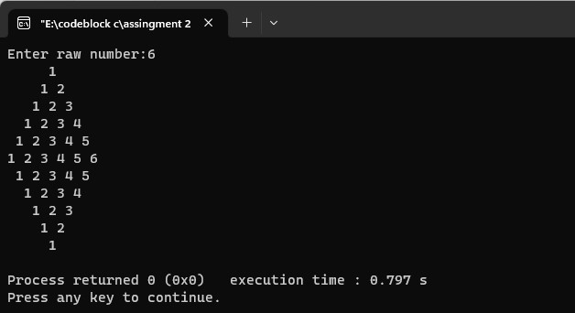

#include<stdio.h> int main()

{ int r,c,n; printf("Enter raw number: "); scanf("%d",&n); for(r=1;r<=n;r++)

{

for(c=1;c<=n;c++) printf("* "); printf("\n");

}

}

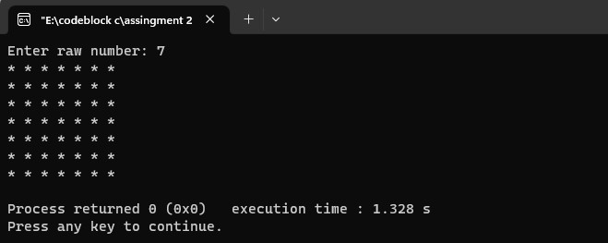

#include<stdio.h> int main() { int n,r,c; printf("Enter raw number: "); scanf("%d",&n); for(r=1;r<=n;r++)

{

for(c=1;c<=n-r;c++)

{ printf(" ");

}

for(c=1;c<=r;c++)

{ printf("* ");

}

printf("\n");

}

}

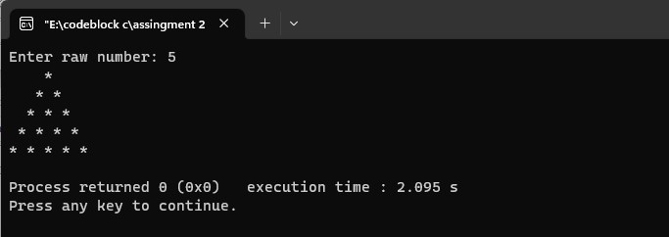

#include<stdio.h> int main()

{ int n,r,c; printf("enter raw number: "); scanf("%d",&n); for(r=n;r>=1;r--)

{

for(c=n-r;c>=1;c--)

{

printf(" ");} for(c=1;c<=r;c++)

{printf("* ");}

printf("\n");

}

}

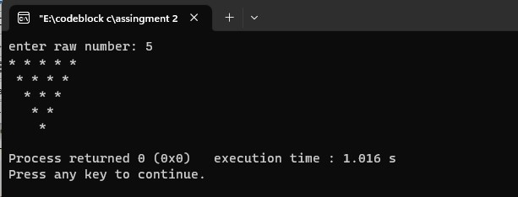

#include<stdio.h>

int main() { int r,c,n; printf("Enter raw number: "); scanf("%d",&n); for(r=1;r<=n;r++)

{

for(c=1;c<=n;c++)

{

if( r==1 || r==n || c==1 || c==n || c==r) printf(" *");

else printf(" ");

} printf("\n");

}

}

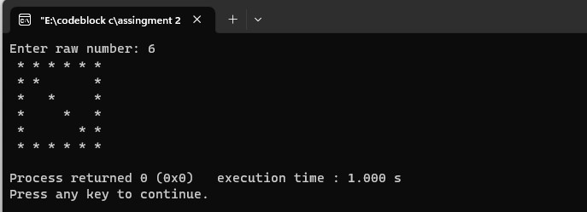

7. Pattern 7 #include<stdio.h> int main() { int r,c,n; printf("Enter raw number: "); scanf("%d",&n); for(r=1;r<=n;r++)

{

for(c=1;c<=n;c++)

{

if( r+c==n+1 || c==r) printf("*");

else printf(" ");

} printf("\n");

}

}

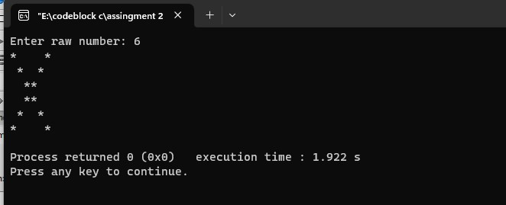

Pattern 8 #include<stdio.h> int main() { int n,r,c,count=0; printf("Enter n: "); scanf("%d",&n); for(r=1;r<=n;r++)

{

for(c=1;c<=r;c++)

{ count++;

printf("%d ",count);

} printf("\n");

}

}

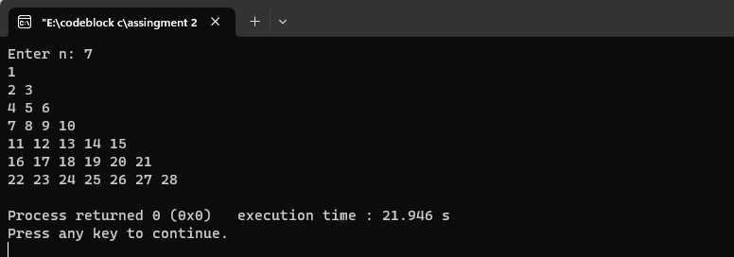

Point grading system

#include<stdio.h> int main() { int mark; printf("Enter Your Marks: "); scanf("%d",&mark); if (mark>=80) printf("You got A+"); else if (mark>=70 && mark<<80) printf("You got A"); else if (mark>=65&& mark<<70) printf("You got A-"); else if (mark>=60&& mark<<65) printf("You got B"); else if (mark>=50&& mark<<60) printf("You got C"); else if (mark>=40&& mark<<50) printf("You got D"); else if (mark>=33&& mark<<40) printf("You got E"); else printf("Failed in exam");

}

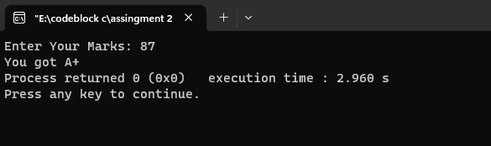

SUM with pointer

#include<stdio.h> int main()

{ int x,y,sum; int *ptr1,*ptr2; printf("Enter two numbers: "); scanf("%d %d",&x,&y); ptr1=&x; ptr2=&y; sum= *ptr1 + *ptr2;

printf("The sum is %d",sum);

}

